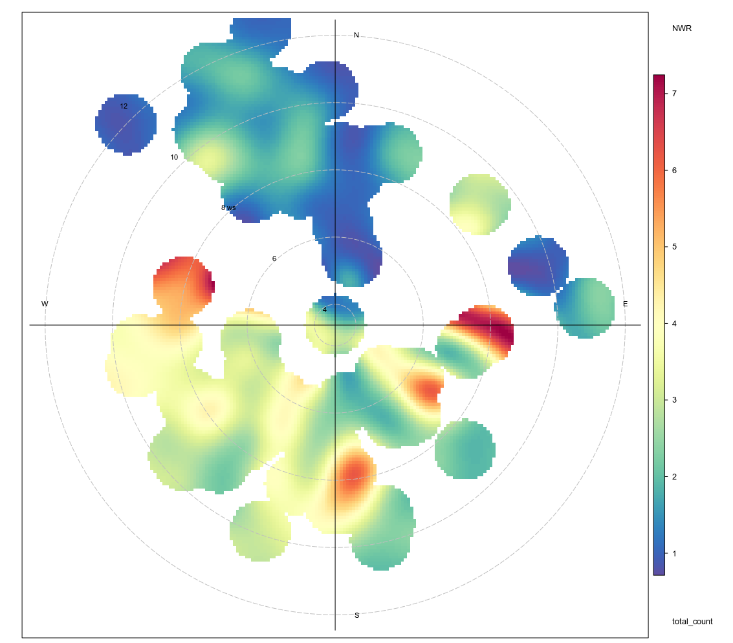
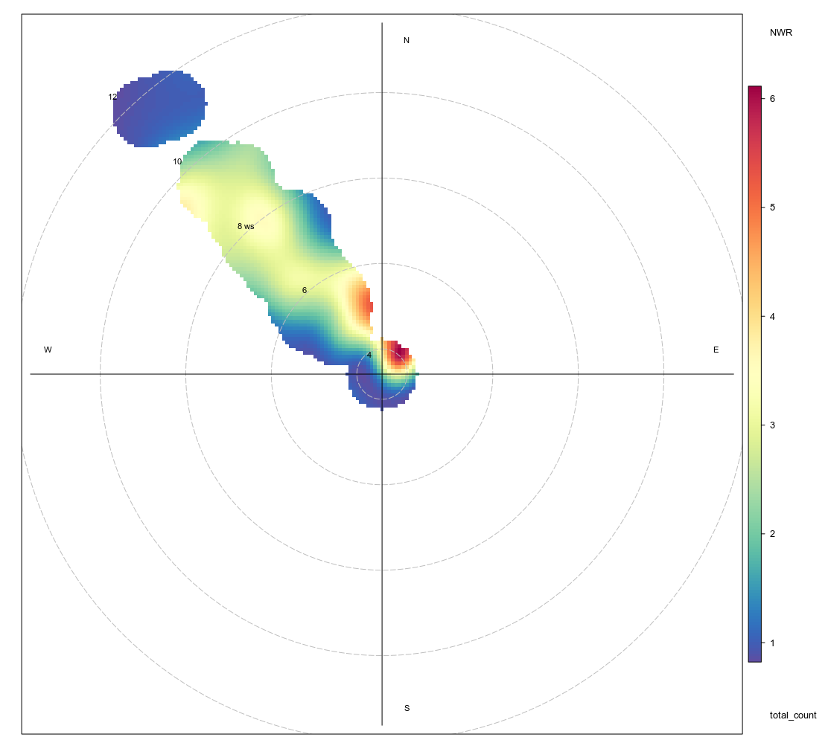
Benguela current
Humboldt current

California current
Canary current
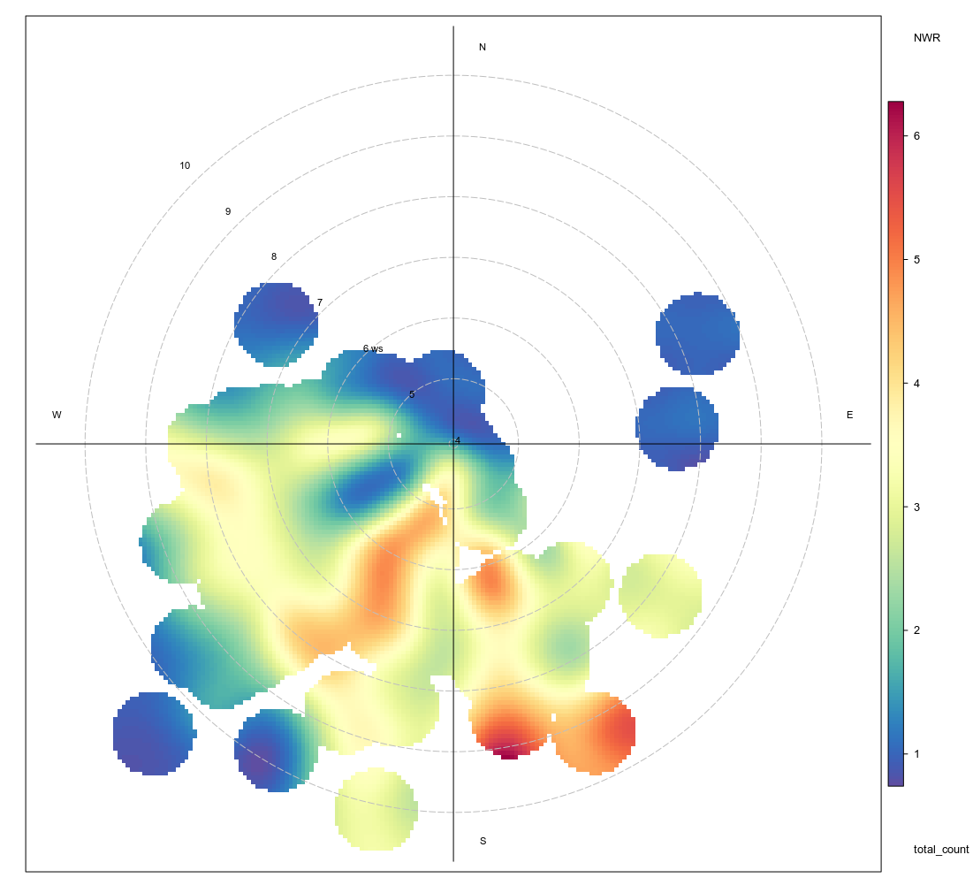
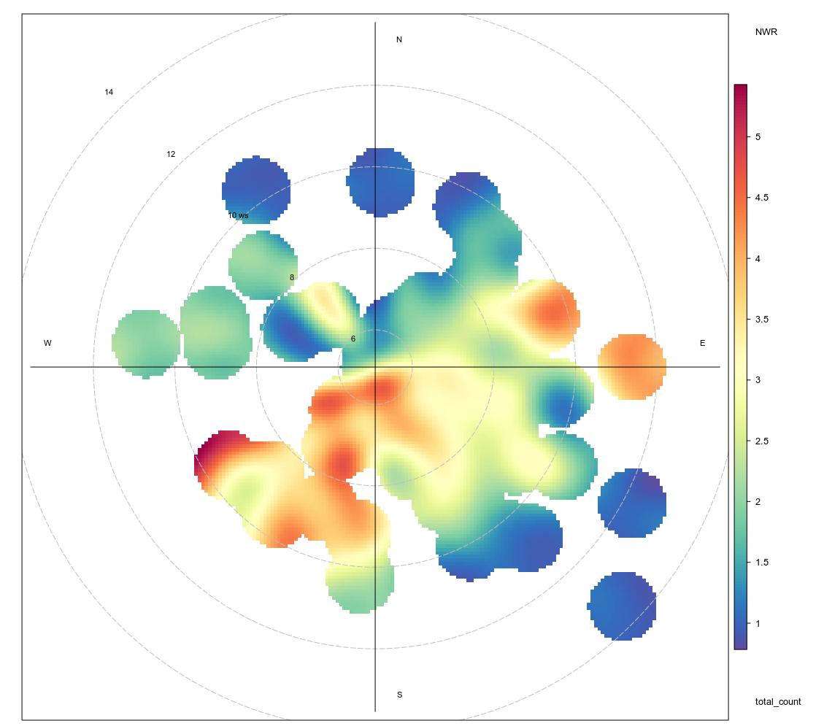

Figure 1: Bivariate polar plot of the total number of signals detected anually from 1982 – 2012. The colour scale shows the total number of signals detected and the radial scale shows the wind speed, which increases from the centreof the plot raidially out-wards.

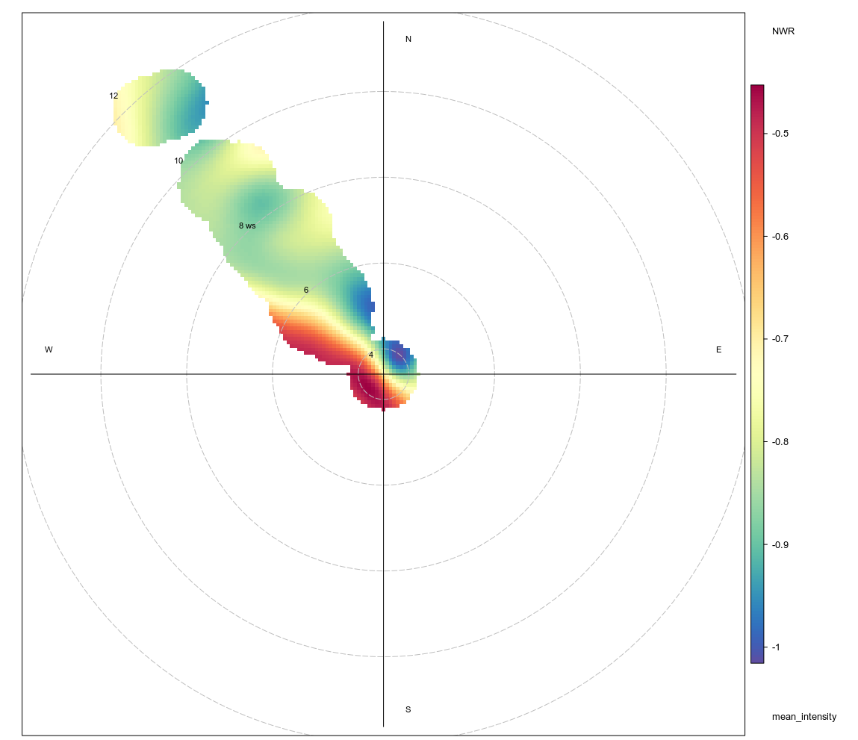
Benguela current
Humboldt current
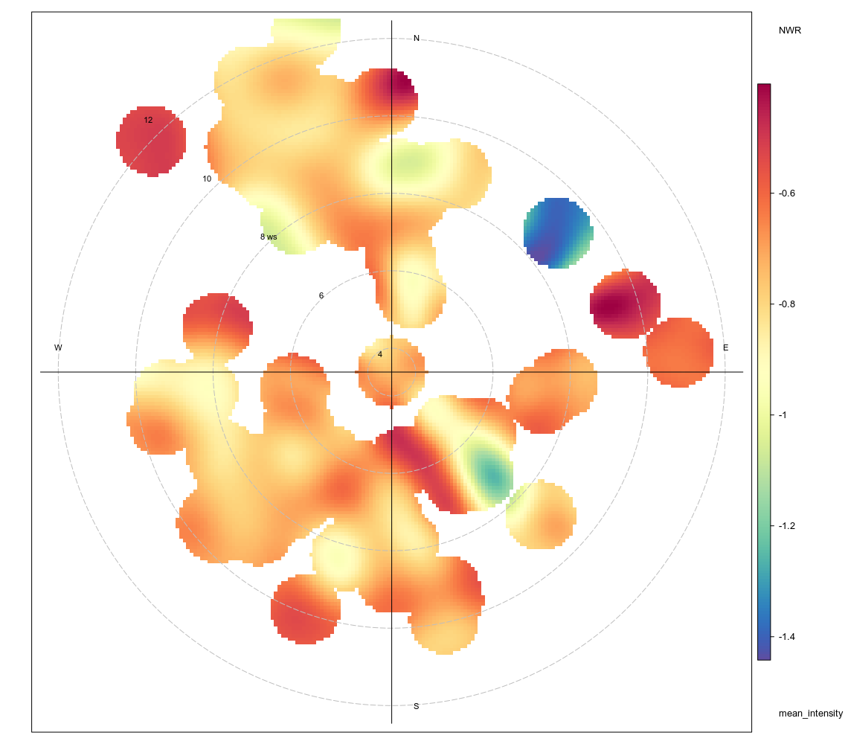

Canary current
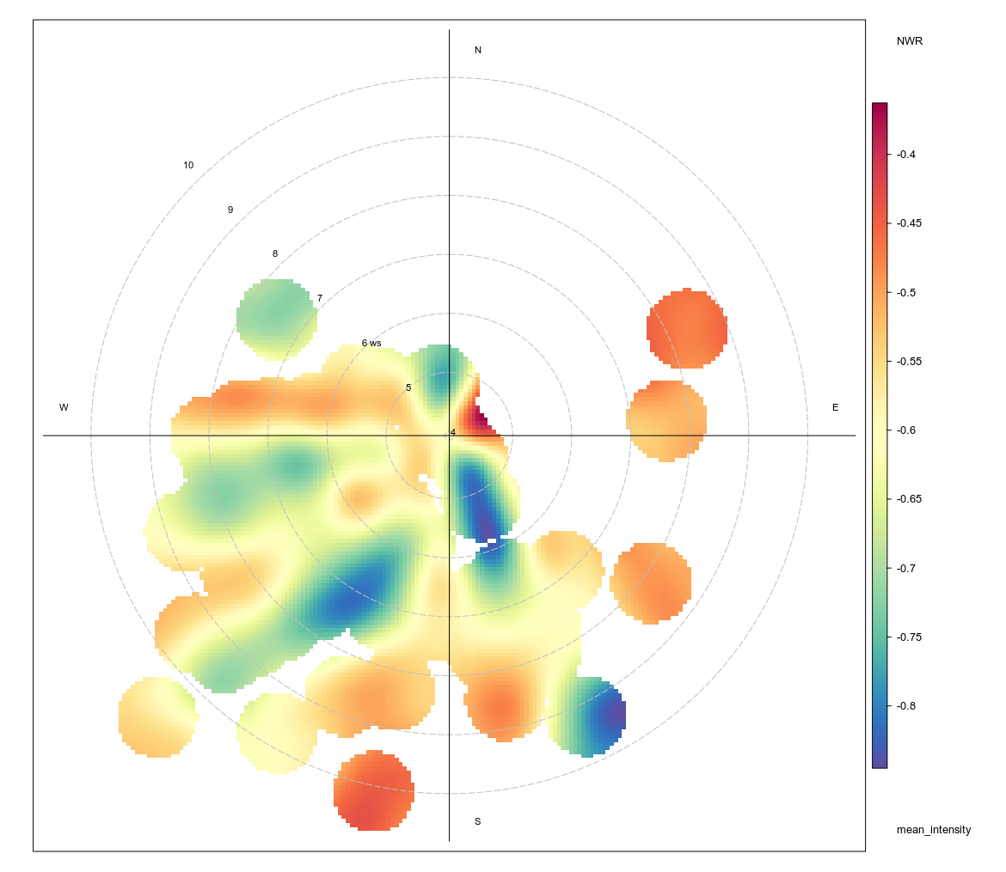
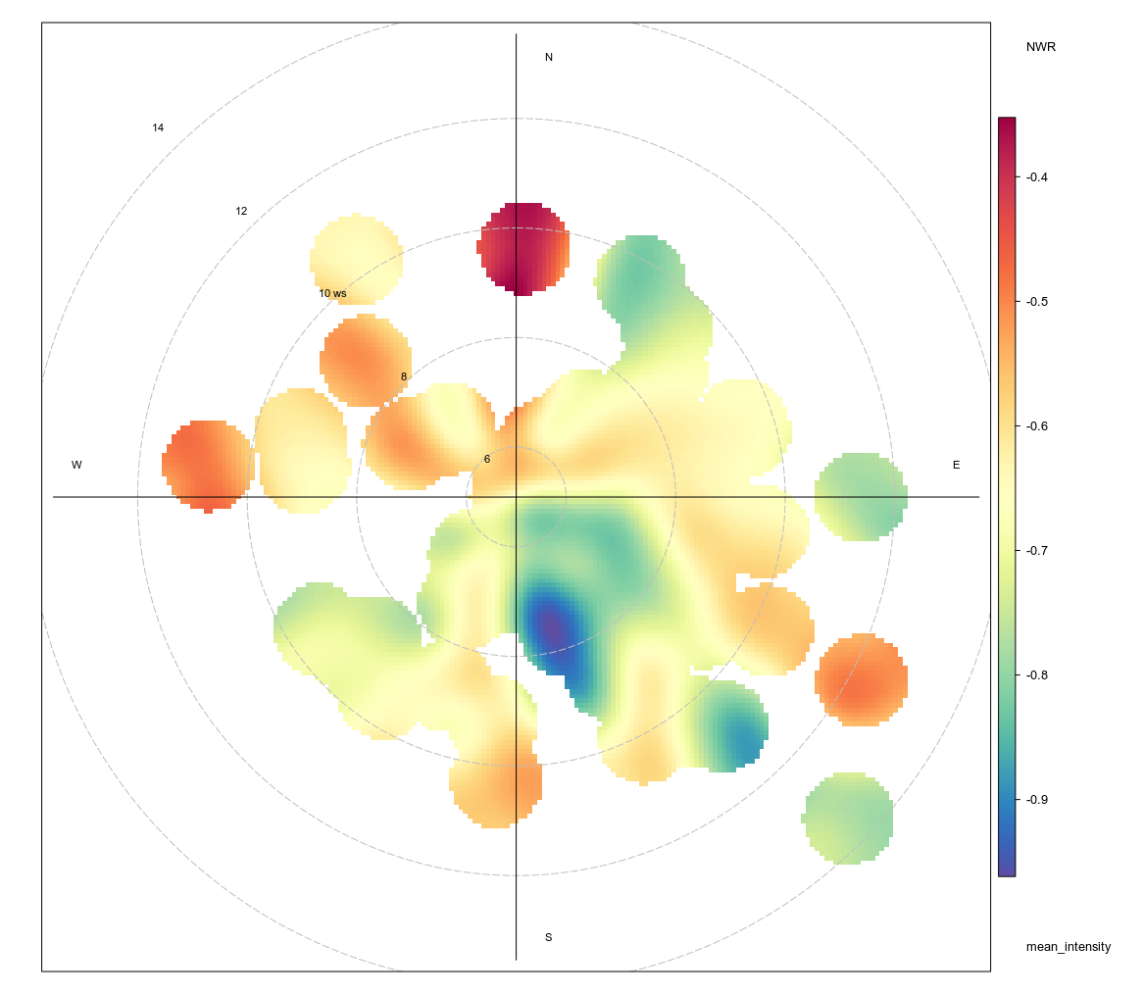
California current

